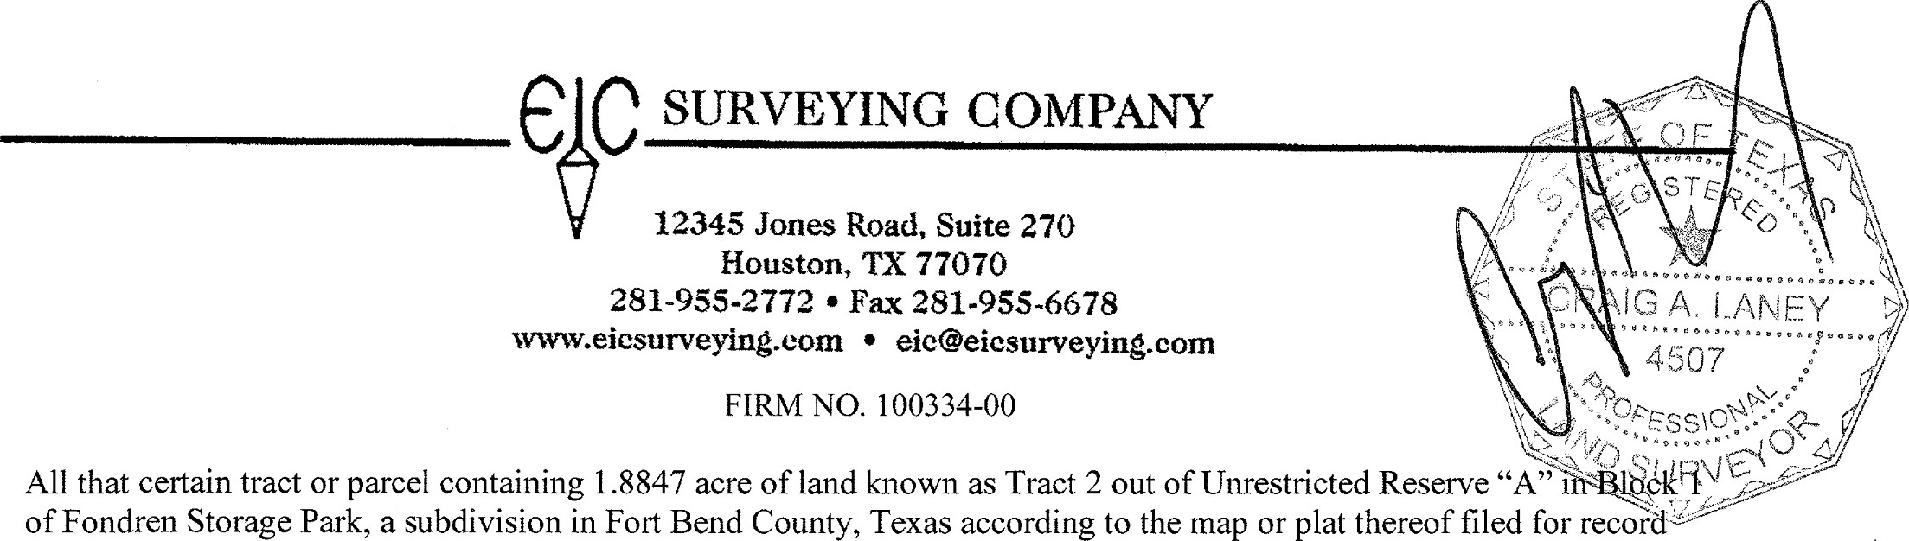
-ANF-Y
All that certain tract or parcel containing 1.8847 acre of land known as Tract 2 out of Unrestricted Reserve "A"hrFBme18^{VC} of Fondren Storage Park, a subdivision in Fort Bend County, Texas according to the map or plat thereof filed for record under Plat Number 20040051 of the Fort Bend County Plat Records, said Tract 2 being more particularly described by metes and bounds as follows:
at a 5/8" iron rod (found) at the Northeast corner of a cut-back corner (found) marking the intersection of the South right-of-way line of Chasewind Drive, (60.00 feet in width), with the East right-of-way line of Fondren Road, (110.00 feet in width), same point marking the Northerly-Northwest corner of said Unrestricted Reserve "A";
THENCE S 75 ⁰ 23 '42" E, a distance of 120.73 feet along the South right-of-way line of said Chasewind Drive and the North line of said Unrestricted Reserve "A" to a 5/8" iron rod with Dmbeard Svcs RPLS 6438 cap (found) marking the Northwest corner and POINT OF BEGINNNG of the herein described Tract 2;
THENCE continuing S 75 ⁰23 '42" E, a distance of 151.43 feet along the South right-of-way line of said Chasewind Drive and the North line of said Unrestricted Reserve "A" to a 5/8" iron rod (found) marking the Northeast corner of said
Unrestricted Reserve "A", the Northwest corner of Lot 38 in said Block 1 and the Northeast corner of the herein described Tract 2;
THENCE S 14⁰03 '36" W, a distance of 177.93 feet along the common line of said Unrestricted Reserve "A" and said Lot
38 to a 5/8" iron rod (found) for angle point in the West line of Lot 37 in said Block 1 and the East line of said Unrestricted Reserve "A";
THENCE S 03 ⁰33 '33" W, a distance of 89.30 feet along the common line of said Unrestricted Reserve "A" and said Lot 37 to a 5/8" iron rod (found) for angle point in the East line of said Unrestricted Reserve "A" marking the Southwest corner of Lot 36 and the Northwest corner of Lot 35, both in said Block 1;
THENCE S 00 ⁰24'45" W, a distance of 221.90 feet along the common line of said Unrestricted Reserve "A" and said Lot 35 to a 5/8" iron rod (found) in the North right-of-way line of a Fort Bend County Drainage Easement as described in an instrument filed for record in Volume 509, Page 380 of the Fort Bend County Deed Records marking the Southwest comer of Lot 34 in said Block 1, the Southeast corner of said Unrestricted Reserve "A" and the Southeast corner of the herein described Tract 2;
THENCE N 89 ⁰ 35' 15" W, a distance of 182.02 feet along the common line of said Fort Bend County Drainage Easement and said Unrestricted Reserve "A" to a 5/8" iron rod (found) marking the Southeast corner of Unrestricted Reserve "B" in said Block 1, the Southerly-Southwest corner of said Unrestricted Reserve "A" and the Southwest corner of the herein described Tract 2;
THENCE N 00 ⁰ 24'45" E, a distance of 216.75 feet along the common line of said Unrestricted Reserve "A" and said Unrestricted Reserve "B" to a 5/8" iron rod (found) marking the Northeast corner of said Unrestricted Reserve "B", an interior corner of said Unrestricted Reserve "A" and an interior corer of the herein described Tract 2;
THENCE S 75 ⁰ 23 '42" E, a distance of 23.21 feet to a 5/8" iron rod with Dmbeard Svcs RPLS 6438 cap (found) marking an interior corner of the herein described Tract 2;
THENCE N 14 ⁰ 02' 55" E, a distance of 174.99 feet to a 5/8" iron rod with Dmbeard Svcs RPLS 6438 cap (found) marking the Southeast corner of the herein described Tract 2;
THENCE N 75 ⁰45 '35" W, a distance of 16.02 feet to a 5/8" iron rod with Dmbeard Svcs RPLS 6438 cap (found) marking an interior corner of the herein described Tract 2;
THENCE N 14⁰08 '46" E, a distance of 139.42 feet to to the POINT OF BEGINNNG and containing 1.8847 acre of land.
Surveyed on the ground July 25, 2019, Revised November 3, 2020.
Job No. 19-403-07. (See corresponding plat)
The basis of bearing is S 75 ⁰ 23 '42" E, along the South right-of-way line of Chasewind Drive per record plat.
Land Boundary Topographic Surveying
A Division ofEverything in Christ Services, Inc.

