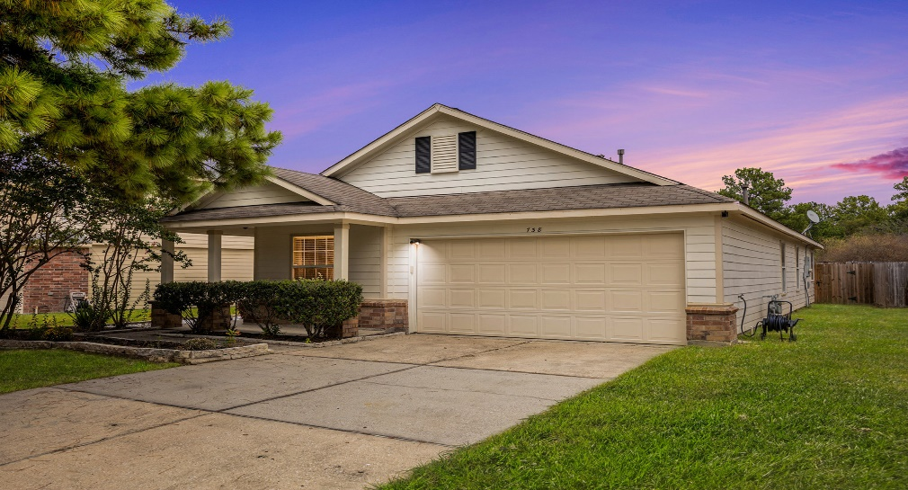
Recent Updates

- Kitchen
  - Cabinets have been painted white
  - Double Oven
  - Granite Countertops
  - Cabinet Hardware
  - Wood Look Laminate flooring

  - Matching Appliances

- Primary Bathroom
  - Updated Shower Faucets
  - Soaking Tub
  - Large Shower
  - New Light Fixtures
  - New Stylish Vanities
  - New Mirrors
  - New Tile Flooring

- Secondary Bathroom
  - Double Sink Vanity
  - New Faucets
  - New Mirrors
  - New Lighting
  - Large Shower with handholds
  - Ne Tile Flooring

- Additional Updates
  - Shelving In the Laundry Room
  - Paint throughout the Entire Home
  - Window Coverings
  - All Baseboards and Trim painted
  - New Flooring Throughout the Home

