4307 Waterbeck Dr Weston Lakes
Feature and Improvement List

Main Interior Features

New paint on all interior walls and baseboards (Feb 2024)
New carpet entire second floor (Feb 2024)
Water heaters replaced - 2 (2020)
A/C upstairs replaced ( 2020)
A/C downstairs replaced (2020)
A/C master bedroom replaced (2021)
Stairs refinished and banisters painted (2024)
Double front doors refinished and painted (2024)
Fireplace refinished with Limewash finish (2024)
New chandeliers in entryway and dining area (2024)
All ceiling fans replaced in entire house (2024)

Main Exterior Features
New fence surrounding home by Apache Fence (2023)
Home entire exterior painted (2022)
Deck redone and outside stair repair (2018)
New rood (2017)
Pool resurfaced (2018)
Landscape added surrounding pool (2018)

Kitchen Features
Kitchen remodel (2024) included:
New Quartz countertops in Kitchen and Butler’s Pantry
New Farmhouse sink with upgraded faucet
Freshley painted cabinets and new cabinet hardware
Added pendant lighting
New tile backsplash
New energy efficient ceiling fan/light in breakfast area

Laundry room Features

New marble countertops installed (2024)
Freshley painted cabinets and new cabinet hardware (2024)
New sink and upgraded faucet (2024)

Feature and Improvement List continued

Primary Bedroom Features

Oversized primary bedroom with view of backyard pool, lake and golf course
New carpet (2023)
Primary bath updatesl (April 2024) includes:
New marble countertop, undermount sinks and faucets
Freshly painted cabinets and new cabinet hardware
New light fixtures

Second Floor bathroom Features

Includes bedroom 3 & 4 Jack and Jill and bedroom 4 ensuite bathroom:
New marble countertops installed in (2024)
New undermount sinks and faucets (2024)
Freshley painted cabinets and new cabinet hardware (2024)
New light fixtures (2024)

Weston Lakes offers a golf court community with restricted gated access, private club, gym and tennis courts, walking trails and beautiful lake views. and more!

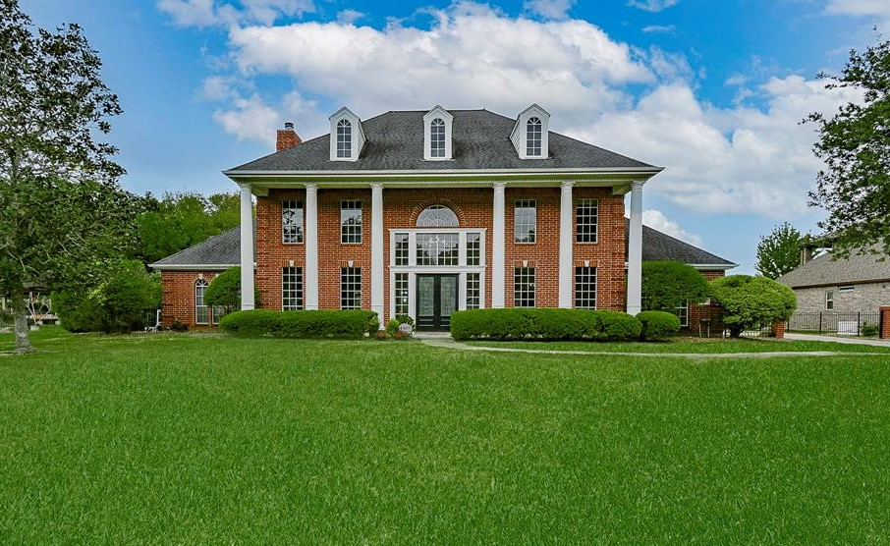
Welcome Home

