Offer Instructions
Thank you for Submitting an offer.
We are committed to professionalism and communication. We look forward to working together to make this a smooth process.

Sellers: GLP Holdings LLC Series I
Legal Description: LT 11 BLK P Sunnyside Place
Preferred Title Co.: American Title Company of Houston
6910 Chetwood
Houston, TX 77081
*Pam Keever
713-995-8200 (p) pkeever@atctx.com (email)

Option Fee: Option fee is $250 for a 7-day option period. In accordance with new TREC guidelines, Option Fee should be remitted to the title company along with Earnest Money.
Earnest Money: Please provide 1% of the Sales Price.
Seller’s Disclosure: This Disclosure is attached to MLS documents. Please present a signed copy with your offer.
HOA Addendum: N/A
Sending your Offer: Send all agent inquiries and offers to hmsolutions1@yahoo.com
Exclusions: None

Broker Information
Broker: Tracey Richardson Listing Associate: Kay Hayes
Broker License: 451583 Associate License: 610051
Broker email: trich1983@gmail.com Associate Email: hmsolutions1@yahoo.com
Office Address: 1010 Spring Cypress Rd. #109 Associate Phone: 832-334-9026
Spring, TX 77373
Office Phone: 281-706-5938 or 281-373-0616

Kay Hayes, Realtor
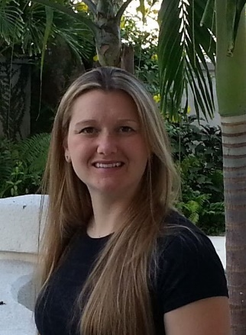
832-334-9026

