13203 Parkway Glen Drive, Houston, TX 77077.

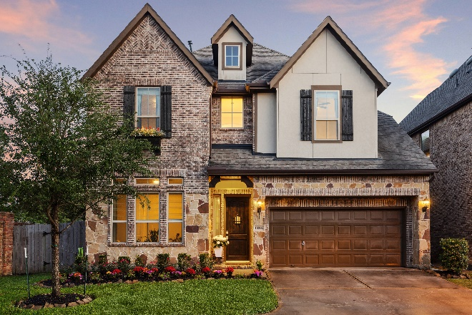

House Overview
Bedrooms 5 (one can be a study)
Baths 4
House SF 3384 (per HCAD)
Lot Size SF 5793 (per HCAD)
Year Built 2017 (per HCAD)
Garage Attached 2 car.

KEY FEATURES

Built by K. Hovnanian Homes
Original owners
End of cul-de-sac location surrounded by a gorgeous brick wall on 2 sides.
No immediate neighbors on two sides so most views out the windows are leafy and green.
Many upgrades (see next page)
Not in a flood zone
Abundant natural light
Brick and stone exterior. Covered back patio.
Outdoor grill and kitchen

FINISHES/UPGRADES

Neutral paint throughout.
Engineered oak hardwood floors in living areas.
Shower added to half bath to make it a full bath – accessible for first floor bedroom.
Oversized garage
Upgraded quartz countertops in kitchen and primary bath.
White kitchen cabinetry
Venetian marble countertops in secondary bathrooms
Stainless, farmhouse apron sink
Abundant, large windows - almost all are operable and open versus non operable seen in newer construction. An upgrade.
Custom lighting in dining, living and pendant lighting in kitchen.
LED lighting throughout
Under cabinet lighting in kitchen
Kitchen island
Breakfast bar seating
Wet bar in game room
Closed off guest suite with full bath and bedroom.
Media room
Huge, understairs closet
Oversized, frameless glass shower in primary bathroom
Crown molding
Tray ceiling in primary bedroom
Wrought iron stair railings.
Custom window coverings – a mix of blinds and drapes
Upgraded carpets and pad on second floor.
Upgraded tile in primary bathroom.
Upgraded bathroom mirrors (framed)
Custom built, glass fronted storage cabinet in living room
Upgraded front door keypad lock
AT and T fiber high speed internet throughout the house
Sprinkler system
Tech-shield radiant barrier roofing decking
Gas Log Fireplace with cast stone surround and mantle
Upgraded tile on fireplace surround.

APPLIANCES
All stainless steel
GE 30” gas burner cooktop
Variable speed vent hood
GE Oven
GE Dishwasher
Stainless refrigerator with freezer.
Stainless steel dishwasher

HOA
$1500 a year. Includes pool, gate and community landscaping, biweekly trash pickup and once weekly recycling.

NON REALTY
Kitchen Refrigerator, washer, and dryer.
Gameroom fridge
All TV’s
Much of the furniture is available including the pool table, outdoor furniture.
All window coverings include custom made drapes.

EXCLUSIONS
None

UTILITY BILLS (SEE NEXT PAGE)
Electricity Average. $250 pm
Water Average $85pm
Gas Average $50pm

COMMUNITY AMNENITIES
Pool
Clubhouse
Grilling area
Gathering area
Playpark
Grassy areas
Lake
Gate

Information provided per seller.
© Keller Williams Metropolitan. All Rights Reserved. This material is based upon information which we consider reliable but because it has been supplied by third parties; we cannot represent whether it is accurate or complete and it should not be relied upon as such. This offering is subject to errors, omissions, changes including price or withdrawal without notice. All info per seller. Some of the information the current sellers have was provided by the original builder. Room sizes, square footage, school zoning, grade availability, “walkability” and any feature in the home or about the home that is important to the buyer should be independently verified.
Please do not include this document as part of any contract. It is for informational purposes only.

