2205 Shadybend Dr,
Pearland, TX 77581

For Sale $455K (Please take 1)
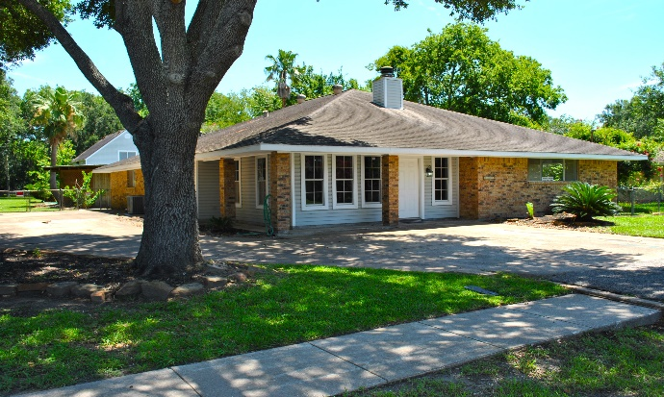

House info:
One story, 4 bedroom, 3 full baths, study w/ side entry door, dining, breakfast room, double gas fireplace. House has two central HVAC systems. Previous has lifetime foundation transferable warranty through Allied Foundation. Seller is providing a 12 month Home Warranty with purchase.

Has brand new…
1 Central A/C & heater (Dakin w/warranty for new homeowner)
Electrical Panel / Breaker Box
Trees trimmed
Facia boards & soffits
Added R-60 Cellulose Blow-in insulation to attic
GE Stainless Gas range stove
GE Stainless Microwave
GE Stainless Dishwasher
Tile flooring in kitchen & baths
Laminate wood floors through-out
Door knobs
Most all ceiling fans & light fixtures
Bathroom mirrors
All Toilets
2 bathrooms vanities
2 new tiled shower/tub
All faucets (kitchen & bathrooms)
Quartz countertops in kitchen & master bath
Double stainless sink & garbage disposal in kitchen
Pool pump motor & water feature pump & multi-valve handle.
Pool was drained and acid wash
Paint throughout

For showing appointments, questions, offers etc.
Text Amy 832-419-6966 / movingwithamy@yahoo.com
UTR-Texas, Realtors

Garage Apartment info:
1 bedroom, living room, loft, kitchenette & full bathroom. Has brand new a/c window unit. Keep in mind it had/has central a/c with duct work etc but just not working. Could add new a/c later. Two long closets for storage & clothes etc. Rental rate value $700 + a month

Has brand new…
kitchenette = countertop w/ double sinks & faucet & garbage disposal
Microwave
Light fixtures
Ceiling fan
Bath vanity, countertop & faucet
A/C window unit (needs to be installed)
Toilet
Laminate wood floors
Paint
Door knobs

Lot info:
Spacious backyard w/ In-ground pool, large covered bar /entertaining area and covered patios. Front driveway could fix 2-4 cars & side driveway extends about 2-3 deep on side of house. Allowed and has great parking trailer, boat, RV etc. Nice mature landscaping and once spring & summer come will be full and lush again. Has 2 car garage with an office to the back right inside garage.

This house has had a lot of work done and updates etc. There is always more can be done. It has so much potential. Create with your person touches and enjoy making it your & your family’s new home

